Model Documentation
1D Solver

CFD code based on an AUSM scheme
with grid management and post processing scripts

Baptiste Romain
Table des matières
Introduction 3
Motivations 3
Results 3
Content of the report 3
Input data 4
Meshing 6
Grid Management 7
Solver 8
Spatial scheme: AUSM 8
Time scheme: Forward Euler 8
Post processing 9

Introduction

Motivations
This 1D compressible and non iso temperature CFD code was developed in April 2024. Its goal was to have a simple environment to verify the equations of the AUSM flux split that have been implemented during the AE6042 CFD project (attended at Georgia Tech) in the 2D code from which it derives.
This 2D code showed oscillatory behavior even while running with a 1st order spatial derivative. However, I was unable to clearly identify the source of the problem, especially knowing that the code was hardly readable because it was coded exclusively with numpy (and no python for loop) for efficiency reasons.
For this new version of the code, and in an attempt to finally make it work, the code was developed only with for loops and with no help of the numpy module.

Results
After testing multiple flux splitting schemes found on the internet, one of them reduced greatly the oscillatory behavior. In addition, with a lower limit of 100K implemented in the function extracting temperature, the oscillations were delt with. However, we can note that the code seems to give results a bit far from the physical reality for low Mach number (incompressible flows) and for trans critical flows.

Content of the report
This report will expose the main component of the codes (input data, meshing, grid management, solver, and post processing) from the equations/physical point of view, but also briefly from the codding perspective.

Input data
The code uses the constant thermodynamic values of air computed for ambient temperature. As the code does not model combustion processes, temperature values are varying in a narrow range. Thus, implementing temperature dependent values was not a priority (although this possibility was kept in mind while programming so that it will be easy to add).
Those values are the following:
$R=8.314462661812324$ : Perfect gas constant$MW=28.96e-3$ : Molecular weight of air$r=\frac{R}{MW}$ : Reduced perfect gas constant for air
$γ=1.400$ : Heat capacity ratio
$C_{p}=1005$ : Constant pressure heat capacity

Initial conditions and grid:
The 2D grid that we were given for the initial project was representative of a diamond airfoil and was the following:
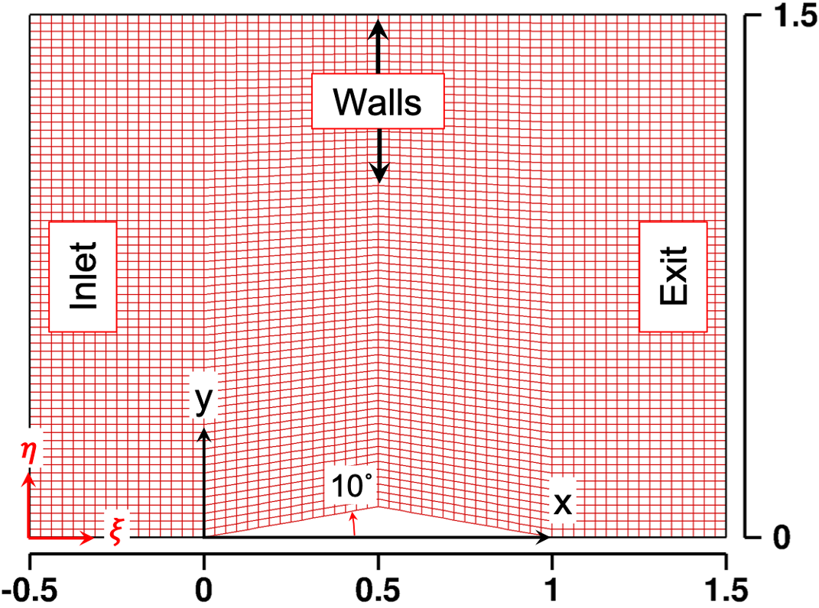
For this 1D solver, the grid used recreated the section of the 2D grid and was the following (a finer version was also used):
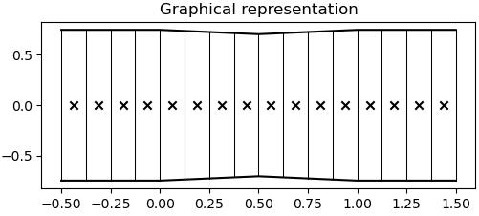
Then, each cell of the grid was then initialized with values derived from temperature, pressure, and Mach number:
$$P_{ini}=101325 Pa$$
$$T_{ini}=300 K$$
$$M_{ini}=2$$
So, we derive:
$$ρ_{ini}=\frac{P_{ini}}{r∙T_{ini}}$$
$$c_{ini}=\sqrt{γ∙r∙T_{ini}}$$
In the end, the state vector is the following for each cell of the grid:
$$\left(\begin{aligned}ρ \\ ρu \\ ρe_{t}\end{aligned}\right)=\left(\begin{aligned}ρ_{ini} \\ ρ_{ini}∙M_{ini}∙c_{ini} \\ \frac{P_{ini}}{γ-1}+\frac{ρ_{ini}}{2}{\left(M_{ini}∙c_{ini}\right)}^{2}\end{aligned}\right)$$

Meshing
The 2D grid that we were given for the initial project was representative of a diamond airfoil and was the following:
For this 1D solver, the grid used recreated the section of the 2D grid and was the following (a finer version was also used):
The part of the project that allows you to create grids is stored in code > 1D > mailleur > create_grid.py
You first have to set the storage path and the name of the grid you want to create. Then, the nodes and sections lists define the points between which you will have a smooth section variation. For instance, in the above grid, the nodes and sections variables contain points to represent x and S at x =-0.5;0;1;1.5
Then, the n_node variable defines the number of subdivisions that you want between each point of the nodes variable.

Grid Management

Main principles
The grid management part of the code (stored in code > 1D > grid_managment) takes for input the path of the grid we want to use for the simulation. The input files (stored in grids > 1D) represents the nodes and associated surfaces of consecutive points. This way of writing the grid is the typical way used for finite difference methods.
Multiple classes were developed to handle the reading and creation of a grid that can be used for applying a CFD scheme. First, we treat the grid as a purely geometrical element. The first class is thus used to read the input file, plot the resulting grid, and also to augment the grid (as we have to add shadow cells for a CFD scheme to be used). Thene, as we use a finite volume method, we transform the grid defined with nodes to a grid defined by cells. To do so, we created a class called cell, that regroup every attribute of the cells (centroid, left and right surfaces, …). Finally, the grid is transformed into a computational grid. To do so, every cell is converted to a computational cell. That is the moment during which every cell is given a state vector. We also wake the normal grid and augmented grid pointing to the same computational cell objects, so that we can use both grid indifferently.

Detailed explanation
The very root of the code is the cell class

Solver

Spatial scheme: AUSM

Time scheme: Forward Euler

Post processing

Tutorial on the way to use the code

